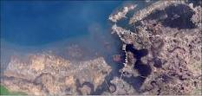

The shifting in earth tectonic plates: WHICH LEADS TO EARTHQUAKES?
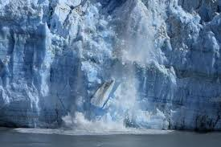The melting of glaciers in antatica causes a rise in sea level and causes a shift in sea bed plates.

